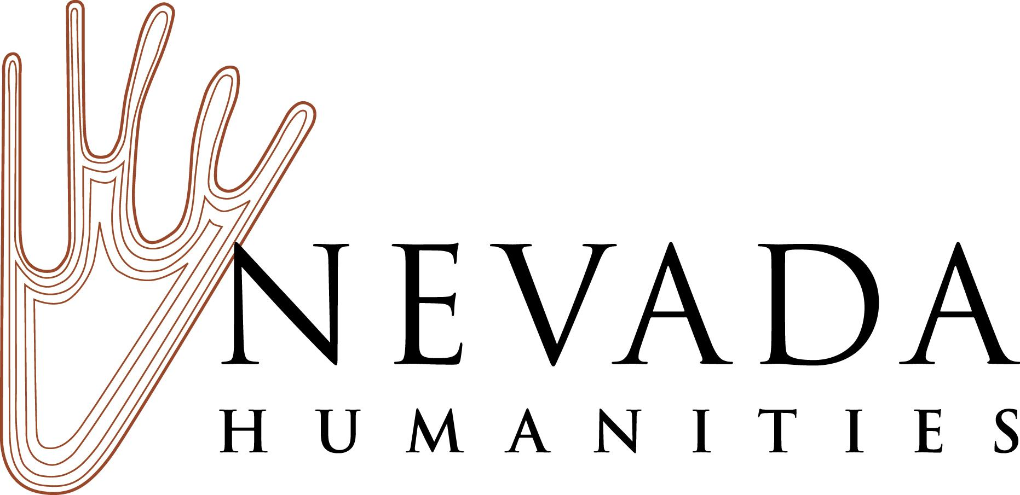

Nevada Humanities Project Grants
2019 Final Report Checklist

Your final project report is due within 90 days of the last scheduled activity for your project. Your final report should include the following components:

☐ Final financial statement, showing actual revenues and expenses for the project.
Keep all materials related to your project organized for the completion of your final budget.

☐ Was your grant selected for a desk audit? If so, you are required to provide copies of information documenting revenues and all expenses for your project such as: contracts, receipts, invoices, in-kind contribution documentation, rental fees, volunteer time sheets, and staff costs.

☐ A written request for the final payment of 10% of your grant award in the exact amount or a check for any unused grant funds payable to Nevada Humanities, as needed to close the grant.

☐ A narrative evaluation of the project, responding to each question in the Final Report and Project Evaluation Form.

☐ If you have publication quality photos from your event, please attach them as email attachments along with your report. Include identification of the photographer, the people and events pictured, and the date the photograph was taken.

☐ If you conducted an audience survey or had audiences fill out an evaluation, please provide us with a copy of the questionnaire used and a summary of the data collected.

☐ If your grant created publications or media products, please send two copies to Nevada Humanities’ Reno office: Nevada Humanities, P.O. Box 8029, Reno, NV 89507.

☐ Provide cover letter copies, and email or mailing list documenting the following:

As a recipient of funding from Nevada Humanities, you were required to send program announcements or invitations to Nevada Humanities staff in Reno and in Las Vegas, members of the Nevada Humanities Board of Trustees, and our state’s elected officials. Provide documentation of your mailings, which credits Nevada Humanities and the National Endowment for the Humanities as a sponsor, to:
- Nevada Humanities staff at both Reno and Las Vegas offices
- Nevada Humanities Board of Trustees Members
- Nevada U.S. Senators and Members of the U.S. House of Representatives
- Nevada Governor’s Office
- State senator and assembly member for your state legislative districts
- National Endowment for the Humanities

Submit the final narrative and fiscal reports as PDF documents to Nevada Humanities at grants@nevadahumanities.org. NOTE: The final report and all documents must have the name of your organization and grant number as both the file name and as the email subject line.

If you need assistance, please contact Nevada Humanities’ grants manager, Bobbie Ann Howell, in our Las Vegas office at 702-800-4670, or via email at grants@nevadahumanities.org.

