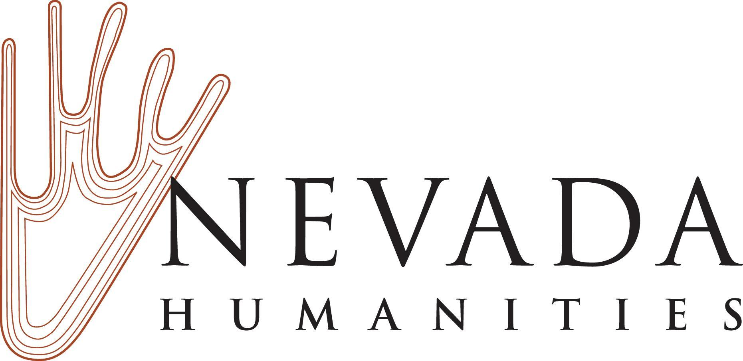

FY2021 Nevada Humanities Mini-Grant and Planning Grant Budget Form

Organization Name:

Type of Grant: ⃞ Mini-Grant
⃞ Planning Grant

Fiscal Summary
Enter your summary information below.

Nevada Humanities Project Grant Amount Requested:
Organization’s Estimated Cost Share:
Total Cost of Project:
Period of Performance:
(For FY2021 Mini-Grants or Planning Grants estimate your project start date and note the last date of the public events or planning process related to your project)

Funding Levels
You may request funds up to the following amounts depending on the type of grant being applied for:

- Mini-Grant: Up to $2,000
- Planning Grant: Up to $1,000

Period of Performance
Your grant Period of Performance depends on the type of grant you are applying for. The Period of Performance for Mini-Grants and Planning Grants begins with the date of the grant award and ends on the date of the completion of the last public event or public/planning component of the project. Your project final report is due 90 days from the date of the last public event or public component of the project. For example, if your Mini-Grant or Planning Grant is awarded on January 1, 2021, and your event takes place on March 1, 2021, your grant Period of Performance is January 1, 2021 - March 1, 2021. Your final report would be due on or before May 29, 2021.

You must expend the allocated grant within the appropriate window of time determined by the Period of Performance. Expenses that extend beyond the grant Period of Performance may be prorated for the duration of the grant Period of Performance (for example, salary expenses may be included as cash cost share, but prorated only for the period of time covered by the grant Period of Performance).

Matching Funds and Cost Share
Nevada Humanities project grants are for the development and implementation of public humanities projects and require you to match the grant at least 1:1. The total match (also known as cost share) must be equal to, or greater than, the amount of the grant request. At least 15% of the grant request must be matched with cash. After you meet your 15% minimum cash match, you may match the remaining funds with a mixture of cash and in-kind cost share. We encourage you to include all of your appropriate project costs in your cash and in-kind match. Your cost share should include the total cost of your project even if it exceeds your 1:1 match requirement.

Cost share is the portion of project costs not paid by federal funds during the grant period of performance. In short, more than one entity shares in the costs of the project with the grantor supplying some of the project funds and the grantee supplying the remainder of the project funds. Cost share funds may consist of applicant cash or third party in-kind contributions. This might include expenses not paid for by your Nevada Humanities project grant, including salary and benefits, facilities and other operating costs, and additional program costs leveraged by your grant. Note that you may not use federal funds as cost share.

Project Budget
Fill out the form below. Please provide clear descriptions and detail in the Notes column for the expenses you are requesting support for. Feel free to provide additional notes or information beneath the form.

Project Expenses | Notes and Expense Detail | Itemized NH Grant  Request | Estimated Cost Share  Organization’s Funds |  | Total
 | Provide detail in this column that outlines your expenses and explains how you arrived at the estimated cost. | Include the amount of NH grant funding that will be spent on the costs below. This column’s total should equal the amount of grant funding requested. | Cash:  List organization’s cash contributed in each category (this includes grants, donations, etc.). | In-Kind: List the values for  In-kind donations of services, facilities, publicity, etc., contributed in each category. | List totals for each expense row below.
Permanent Personnel (salary and benefits)  Note that project grant funds cannot be used to cover expenses for permanent personnel salary or benefits, but these costs can be used as a cash match for the grant. |  | $ | $ | $ | $
Contracted Services |  | $ | $ | $ | $
Honoraria and Artistic Fees |  | $ | $ | $ | $
Travel, Per Diem, and Lodging |  | $ | $ | $ | $
Promotion/Marketing |  | $ | $ | $ | $
Technical Services |  | $ | $ | $ | $
Facilities |  | $ | $ | $ | $
Supplies |  | $ | $ | $ | $
Other Costs (describe in notes section)
Total Project Costs  List the totals for each column in the blue boxes and then list the total project cost - including grant and cost share - in the green box. |  | Total Grant Request = $ | Total Cash Cost Share + Total In-Kind Cost Share = Total Cost Share $ |  | Project Total = $

Sources of Project Income
List any sources of cash and in-kind support for your project in the space below. For example, list sources for your organization's own funds, grants, donations, sponsorships, registration fees, ticket sales, and other sources of income. Please note if these sources are confirmed or anticipated.

Source of Income | Amount $ | Anticipated (A) or Confirmed (C)?

Are any matching funds federal funds?

⃞ Yes ⃞ No

If yes, please describe below.

All grantees are prohibited from using the cost share reported to Nevada Humanities to match other federal grants they may receive, and conversely, they cannot use Nevada Humanities federal grant funds to match other federal sources of funding.

Additional Budget Notes:

Uploading the Budget Form into Your Application
After you complete the Budget Form, convert it to a .pdf format and upload the form into your Nevada Humanities grant application using our online grant portal.

